PRESS RELEASE

September 30, 2013

For immediate release

Sinister 7 Raises the Bar With 100 Miles



Southern Alberta's epic mountain running event, the Sinister 7 Ultra, has something more in store for competitors in 2014. The race directors hinted at the awards ceremony of the 2013 event that they would be making a big announcement regarding the race. “We’re making the Sinister 7 a 100-miler,” says course designer Andrew Fairhurst. At 148km (92 miles), the race was already close to the 100-mile mark and adding the extra distance is prompted by ongoing requests from endurance runners. “We listened to our competitors. We had been brainstorming on doing something bigger with the race for over a year, and this was it”, adds Fairhurst. 100-mile races are held by many in the running community as a pinnacle - the grand achievement in trail running.

The change brings the total elevation gain of the race to 5,687m making it one of the highest climbs in any ultramarathon in Canada. The previous cut-off time of 27 hours has been adjusted to 30 hours to give racers extra time to complete the gruelling course. "Finishing in 30 hours on this course is going to be tough", states race director Brian Gallant, "but that's part of the challenge". For those who are not up to the full 100 miles, the organizers also have options for teams of two to seven members, each competing on one of the seven stages of the course. The race takes runners on several different loops through the backcountry around Crowsnest Pass, each featuring a different peak or highlight of the area.

The update comes as the Sinister 7 Ultra enters its 7th season. The race attracts 1,400 registrants each year, including several hundred soloists who run the full distance on their own. The organizers have welcomed runners from across Canada, the USA, Europe, and as far away as Australia. Many are drawn by the reputation of the race but most simply come for the unique challenge and the stunning scenery around Crowsnest Pass. The 2014 Sinister 7 Ultra will be held on July 5-6.

For further information, please contact Andrew Fairhurst at 403-563-0382 / [Andrew@Sinister7.com](mailto:Andrew@Sinister7.com). Please visit <http://www.Sinister7.com> for an overview of the course and full details on the race.

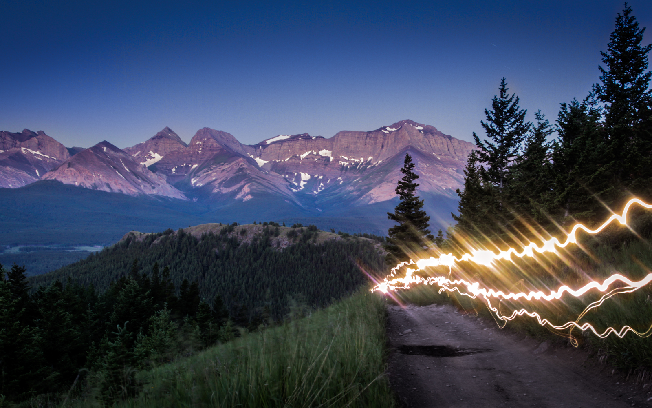

Photo courtesy of Raven Eye Photography